CREATE TABLE ITEMS_EXP09_CSA_41 (

ITEMID INT PRIMARY KEY,

ITEMNAME VARCHAR(50) NOT NULL,

CATEGORY VARCHAR(50),

PRICE DECIMAL(10, 2),

INSTOCK INT CHECK (INSTOCK >= 0)

);

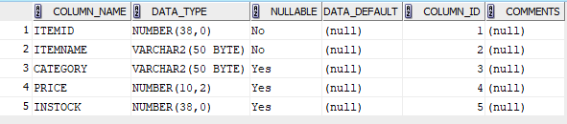

INSERT INTO ITEMS_EXP09_CSA_41 VALUES (1, 'SAMSUNG GALAXYS24', 'ELECTRONICS', 300.00,

50);

INSERT INTO ITEMS_EXP09_CSA_41 VALUES (2, 'IPHONE 15 PRO', 'ELECTRONICS', 800.00, 30);

INSERT INTO ITEMS_EXP09_CSA_41 VALUES (3, 'MACBOOK PRO', 'COMPUTERS', 1400.00, 100);

INSERT INTO ITEMS_EXP09_CSA_41 VALUES (4, 'ASUS VIVOBOOK', 'COMPUTERS',

980.00, 15);

INSERT INTO ITEMS_EXP09_CSA_41 VALUES (5, 'BOAT HEADPHONE ', 'ACCESSORIES', 6000.00,

60);

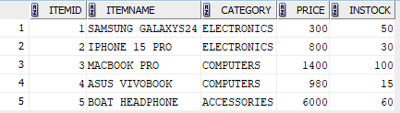

CREATE TABLE CUSTOMERS_EXP09_CSA_41 (

CUSTID INT PRIMARY KEY,

CUSTNAME VARCHAR(50) NOT NULL,

ADDRESS VARCHAR(100),

STATE VARCHAR(50)

);

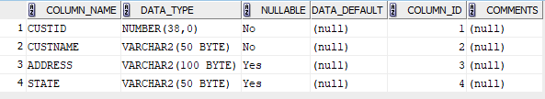

INSERT INTO CUSTOMERS_EXP09_CSA_41 VALUES (1, 'SUSAN JOHN', '303 SPRUCE STREET', 'ILLINOIS');

INSERT INTO CUSTOMERS_EXP09_CSA_41 VALUES (2, 'GEORGE PAUL', '404 ELM STREET',

'NEVADA');

INSERT INTO CUSTOMERS_EXP09_CSA_41 VALUES (3, 'HANNAH MATHEW', '505 WILLOW STREET',

'OHIO');

INSERT INTO CUSTOMERS_EXP09_CSA_41 VALUES (4, 'ELVIN JOE', '606

CHESTNUT STREET', 'MICHIGAN');

INSERT INTO CUSTOMERS_EXP09_CSA_41 VALUES (5, 'JULIA GEORGE', '707 ASH STREET',

'COLORADO');

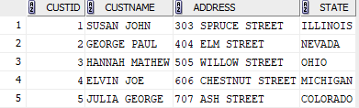

CREATE TABLE ORDERS_EXP09_CSA_41 (

ORDERID INT PRIMARY KEY,

ITEMID INT,

CUSTID INT,

QUANTITY INT ,

ORDERDATE DATE,

FOREIGN KEY (ITEMID) REFERENCES ITEMS_EXP09_CSA_41 (ITEMID),

FOREIGN KEY (CUSTID) REFERENCES CUSTOMERS_EXP09_CSA_41 (CUSTID)

);

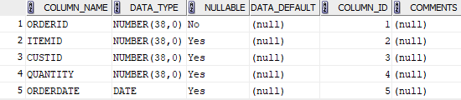

INSERT INTO ORDERS_EXP09_CSA_41

VALUES (1, 1, 1, 1, TO_DATE('2023-02-01', 'YYYY-MM-DD'));

INSERT INTO ORDERS_EXP09_CSA_41

VALUES (2, 2, 2, 2, TO_DATE('2023-03-15', 'YYYY-MM-DD'));

INSERT INTO ORDERS_EXP09_CSA_41

VALUES (3, 3, 3, 1, TO_DATE('2023-04-20', 'YYYY-MM-DD'));

INSERT INTO ORDERS_EXP09_CSA_41

VALUES (4, 4, 4, 1, TO_DATE('2023-05-10', 'YYYY-MM-DD'));

INSERT INTO ORDERS_EXP09_CSA_41

VALUES (5, 5, 1, 3, TO_DATE('2023-06-01', 'YYYY-MM-DD'));

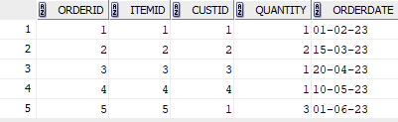

CREATE TABLE DELIVERY_EXP09_CSA_41 (

DELIVERYID INT PRIMARY KEY,

CUSTID INT,

ORDERID INT,

FOREIGN KEY (CUSTID) REFERENCES CUSTOMERS_EXP09_CSA_41 (CUSTID),

FOREIGN KEY (ORDERID) REFERENCES ORDERS_EXP09_CSA_41 (ORDERID)

);

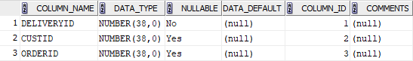

INSERT INTO DELIVERY_EXP09_CSA_41

VALUES (1, 1, 1);

INSERT INTO DELIVERY_EXP09_CSA_41

VALUES (2, 2, 2);

INSERT INTO DELIVERY_EXP09_CSA_41

VALUES (3, 3, 3);

INSERT INTO DELIVERY_EXP09_CSA_41

VALUES (4, 4, 4);

INSERT INTO DELIVERY_EXP09_CSA_41

VALUES (5, 1, 5);

INSERT INTO DELIVERY_EXP09_CSA_41

VALUES (6, 5, 5);

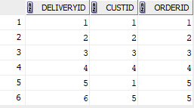

SELECT C.*

FROM CUSTOMERS_EXP09_CSA_41 C

JOIN ORDERS_EXP09_CSA_41 O ON C.CUSTID = O.CUSTID;

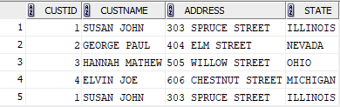

SELECT C.*

FROM CUSTOMERS_EXP09_CSA_41 C

JOIN DELIVERY_EXP09_CSA_41 D ON C.CUSTID = D.CUSTID;

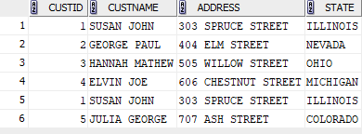

SELECT O.ORDERDATE

FROM ORDERS_EXP09_CSA_41 O

INNER JOIN CUSTOMERS_EXP09_CSA_41 C ON O.CUSTID = C.CUSTID

WHERE C.CUSTNAME LIKE 'S%';

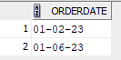

SELECT I.ITEMNAME, I.PRICE

FROM ITEMS_EXP09_CSA_41 I

INNER JOIN ORDERS_EXP09_CSA_41 O ON I.ITEMID = O.ITEMID

INNER JOIN CUSTOMERS_EXP09_CSA_41 C ON O.CUSTID = C.CUSTID

WHERE C.CUSTNAME = 'ELVIN JOE';



SELECT DISTINCT C.CUSTNAME

FROM CUSTOMERS_EXP09_CSA_41 C

JOIN ORDERS_EXP09_CSA_41 O ON C.CUSTID = O.CUSTID

JOIN DELIVERY_EXP09_CSA_41 D ON O.ORDERID = D.ORDERID

INTERSECT

SELECT DISTINCT C.CUSTNAME

FROM CUSTOMERS_EXP09_CSA_41 C

JOIN ORDERS_EXP09_CSA_41 O ON C.CUSTID = O.CUSTID;

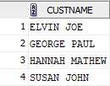

SELECT C.CUSTID, C.CUSTNAME, C.ADDRESS, C.STATE

FROM CUSTOMERS_EXP09_CSA_41 C

JOIN ORDERS_EXP09_CSA_41 O ON C.CUSTID = O.CUSTID

LEFT JOIN DELIVERY_EXP09_CSA_41 D ON O.ORDERID = D.ORDERID

WHERE O.ORDERDATE > TO_DATE('2013-01-01', 'YYYY-MM-DD')

AND D.DELIVERYID IS NULL;



SELECT DISTINCT O.ITEMID

FROM ORDERS_EXP09_CSA_41 O

UNION

SELECT DISTINCT O.ITEMID

FROM ORDERS_EXP09_CSA_41 O

LEFT JOIN DELIVERY_EXP09_CSA_41 D ON O.ORDERID = D.ORDERID

WHERE D.DELIVERYID IS NULL;

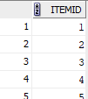

SELECT C.CUSTNAME

FROM CUSTOMERS_EXP09_CSA_41 C

LEFT JOIN ORDERS_EXP09_CSA_41 O ON C.CUSTID = O.CUSTID

LEFT JOIN DELIVERY_EXP09_CSA_41 D ON O.ORDERID = D.ORDERID

WHERE D.DELIVERYID IS NULL

GROUP BY C.CUSTNAME;



SELECT C.CUSTNAME

FROM CUSTOMERS_EXP09_CSA_41 C

JOIN ORDERS_EXP09_CSA_41 O ON C.CUSTID = O.CUSTID

GROUP BY C.CUSTNAME

ORDER BY COUNT(O.ORDERID) DESC

FETCH FIRST 1 ROW ONLY;



SELECT DISTINCT C.*

FROM CUSTOMERS_EXP09_CSA_41 C

JOIN ORDERS_EXP09_CSA_41 O ON C.CUSTID = O.CUSTID

JOIN ITEMS_EXP09_CSA_41 I ON O.ITEMID = I.ITEMID

WHERE I.PRICE > 5000;



SELECT DISTINCT C.CUSTNAME, C.ADDRESS

FROM CUSTOMERS_EXP09_CSA_41 C

LEFT JOIN ORDERS_EXP09_CSA_41 O ON C.CUSTID = O.CUSTID

LEFT JOIN ITEMS_EXP09_CSA_41 I ON O.ITEMID = I.ITEMID AND I.ITEMNAME =

'SAMSUNG GALAXY S24'

WHERE I.ITEMID IS NULL;

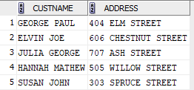

SELECT DISTINCT C.CUSTID, C.CUSTNAME, C.ADDRESS, C.STATE, O.ORDERID, O.ITEMID,

O.QUANTITY, O.ORDERDATE

FROM CUSTOMERS_EXP09_CSA_41 C

LEFT JOIN ORDERS_EXP09_CSA_41 O ON C.CUSTID = O.CUSTID;

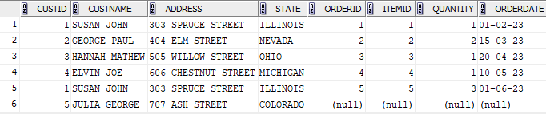

SELECT C.CUSTID, C.CUSTNAME, C.ADDRESS, C.STATE, O.ORDERID, O.ITEMID,

O.QUANTITY, O.ORDERDATE

FROM CUSTOMERS_EXP09_CSA_41 C

RIGHT JOIN ORDERS_EXP09_CSA_41 O ON C.CUSTID = O.CUSTID;

